**EXPERIMENT 2**

**Name :Anmol yadav**

**SAP ID -500083814**

**BATCH - DevOps**

**AIM: Working with Docker (Basic Commands)**

**Steps to Complete:**

1. Search a Redis image on DockerHub

**Command: docker search redis**

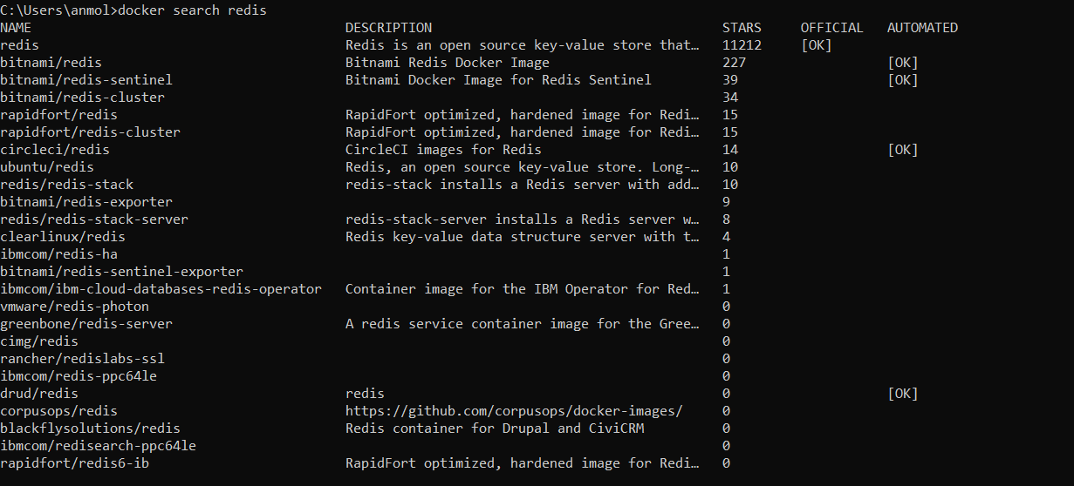

1. Run Docker Container of Redis Image in background

**Command: docker run -d redis**

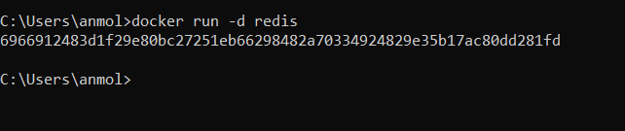

1. Run Docker PS and Docker PS –a

**Command: docker ps**

**Command: docker ps -a**

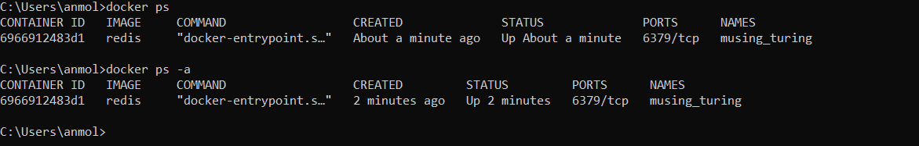

1. Run Docker Container and take its console.

**Command: docker run -it redis /bin/bash**

**ls**

**mkdir directory name**

**ls**

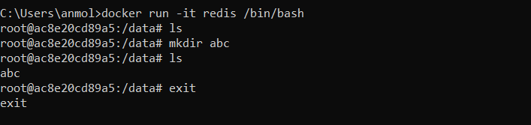

1. Create a Docker Volume and connect it

**Command: docker run -it -v myvol:/data redis /bin/bash**

